PHP PDO

Create a PDO class object

1. Configure data source name, user and password.
2. Initialize PDO object

//Build DSN

$this->dsn = 'mysql:host=' . $this->host . ';dbname=' . $this->dbname;

$options = array(

PDO::ATTR_PERSISTENT => true,

PDO::ATTR_ERRMODE => PDO::ERRMODE_EXCEPTION

);

try {

$this->pdo = new PDO($this->dsn, $this->user, $this->pass, $options);

} catch (PDOException $e) {

$this->error = $e->getMessage();

}

Create Statement class object with prepare function from PDO class

Ex) this->stmt = pdo->prepare(“select query”);

Bind values for stmt

Ex)

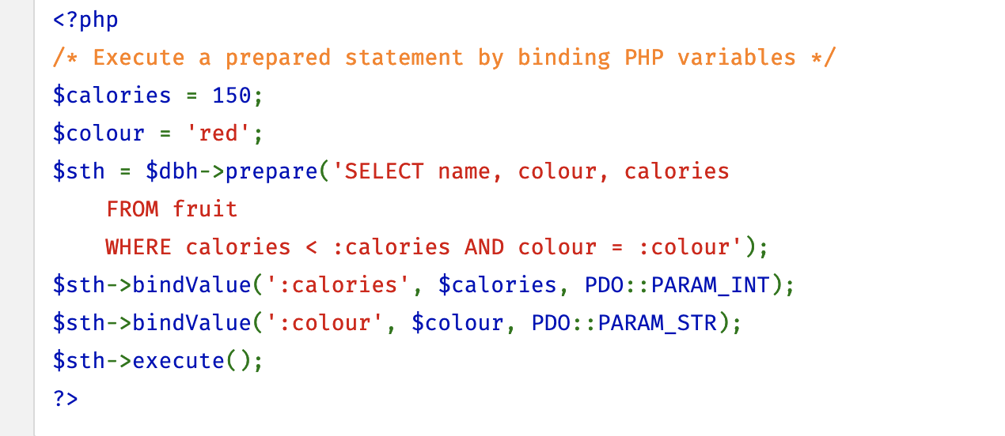

bindValue ( [mixed](http://php.net/manual/en/language.pseudo-types.php#language.types.mixed) $parameter , [mixed](http://php.net/manual/en/language.pseudo-types.php#language.types.mixed) $value [, int $data_type = PDO::PARAM_STR ] ) : bool

return bool

Execute query from statement.

$this->stmt->excute($data);

Data flow

